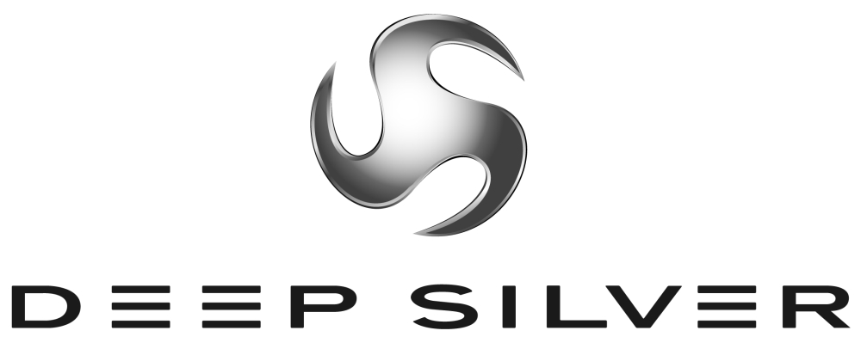
Press Information
Planegg, Germany
International PR Contact:
Martin Metzler
Koch Media GmbH Tel: +49 89 24245-123
Lochhamerstr. 9 Fax: +49 89 24245-3 134
82152 Planegg/Munich m.metzler@kochmedia.com
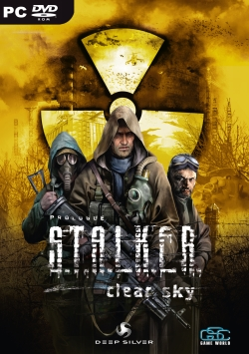

S.T.A.L.K.E.R. – Clear Sky

S.T.A.L.K.E.R.: Clear Sky is a survival FPS game for PC based on a ‘what-if’ scenario of the second Chernobyl Nuclear Power Plant accident. The game is created as a warning to mankind against mindless play with technologies. S.T.A.L.K.E.R.: Clear Sky is the official prequel to the renowned S.T.A.L.K.E.R. game by the Ukraine-based GSC Game World studio. The game is set in 2011and brings forth the events to have preceded the third campaign of Strelok to the Zone center. S.T.A.L.K.E.R.: Clear Sky introduces an alternative look onto the events of the original game and offers the player to try himself out as a mercenary s.t.a.l.k.e.r. in search of his own path in the world of S.T.A.L.K.E.R.

Official game site: www.stalker-game.com

About Deep Silver
Deep Silver develops and distributes interactive games for all platforms. The Deep Silver label means to captivate all computer and video gamers who enjoy and share a passion for thrilling gameplay in modern game worlds. Deep Silver works with its partners to achieve a maximum of success while maintaining the highest possible quality, always focusing on what the customer desires. Deep Silver products are designed to equally appeal to professionals and beginners, children and adults.

Deep Silver has published around 40 games since 2003, including the most successful adventure of 2006, Secret Files: Tunguska, the bestseller ANNO 1701 (co-published with Sunflowers), the challenging CrossworDS knowledge puzzle game, the horse simulation Horse Life DS, and the soccer MMO World of Soccer Online. Current developments include Warhammer® - Battle March™ (in cooperation with Namco Bandai), the action role-playing game Sacred 2: Fallen Angel (in cooperation with Ascaron), S.T.A.L.K.E.R.: Clear Sky, the sinister Chernobyl shooter for PC, and the new game from the Piranha Bytes team. Deep Silver's own developing studio Deep Silver Vienna opened in 2007. For more information please visit www.deepsilver.com

Koch Media is a leading producer and distributor of digital entertainment products (software, games and movies on DVD). The company's own sales activities, marketing and distribution extend throughout Europe, and it has formed strategic alliances with numerous software and games manufacturers: Ascaron, Braingame, D3P, G-Data, Gamelife, Kaspersky Lab, Lexware, Namco Bandai, Pinnacle, Square Enix, Sony Online Entertainment, System3, etc. Headquartered in Planegg near Munich/Germany, Koch Media owns publishing and distribution branches in Germany, England, France, Austria, Switzerland, Italy and the USA. www.kochmedia.com

About GSC Game World and GSC World Publishing:
Founded in 1995 in Kiev, GSC Game World is the leading computer game development company in Ukraine. The launched projects developed by GSC Game World, among others, include the critically acclaimed and multi-million selling Cossacks series, American Conquest, American Conquest: Fight Back, Alexander (Oliver Stone’s movie tie-in), Cossacks II: Napoleonic Wars. The two recently released titles by GSC Game World are Heroes of Annihilated Empires (self-published worldwide by GSC’s proprietary publishing subdivision GSC World Publishing) and the top-selling S.T.A.L.K.E.R.: Shadow of Chernobyl. Currently in development is the official prequel S.T.A.L.K.E.R.: Clear Sky for PC.
Official web-site: www.gsc-game.com

